Instructions for looking up and requesting classes

Before you begin:
- Log in to powerschool (on a computer – not a phone) and click on the ECA Program Completion Audit icon to see the requirements that you have met
  - If there is a mistake on the audit, please email records@earlycollegealliance.info to fix if needed
- Have your E number handy or memorized and your EDP open
- Open the General Ed requirements link

Looking up classes:
- Log on to your myemich account
- Click on Student Registration in the Student Academic Services tile
- Click on Browse Classes
- In the pull down menu for “select a term for Class Search”, choose the term you are looking for (ex. Winter 2026) and click on continue
- If you know the class you are looking for (for example, Comm 124 Speech - you can type “communication” in the subject box and “124” in the course number box and hit search and you will see something like this:
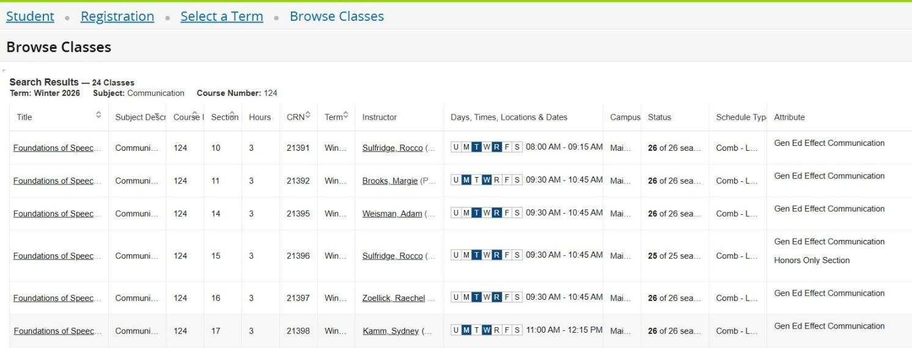

- Choose the course you are interested in from the list that comes up. (You can change the number of sections that show per page at the bottom to see all of the sections at once). Here is help interpreting the columns:
  - The CRN is the course number and must be included in your schedule request
  - The days, times tell you when the class meets.
      - U = Sunday (not common) and R = Thursday
      - If you hover over the days/times, it will also tell you the building and room number (or if the class is online)
  - Status – tells you if there are any seats available – however ECA caps the number of ECA students in a section so just because there are EMU seats does not mean that there is ECA space
  - Attribute tells you if the class meets a general ed requirement, is an honors section or is a restricted section (you cannot register for honors sections)

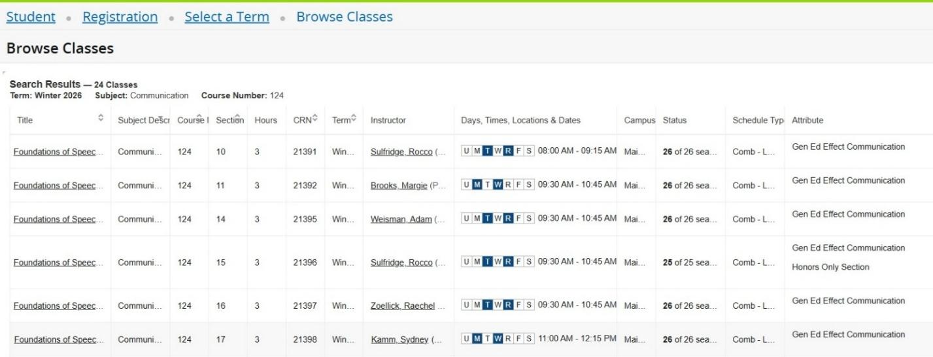
Using the above list of choices as an example, there is 1 COMM 124 section that you cannot request because it is an honors section (CRN 21396)
Under the Attribute column, you can also see that this class will count as a general ed requirement and will fulfill the Effective Communication requirement. When you look up other gen ed classes, they will be identified in the Attribute column.
- Let’s say that you are a morning person, and you like the MW 8-9:15 class. Now what?
- Look for the CRN, Subject Description, Course #, title, day/time and number of credits and transfer them to the schedule request form:
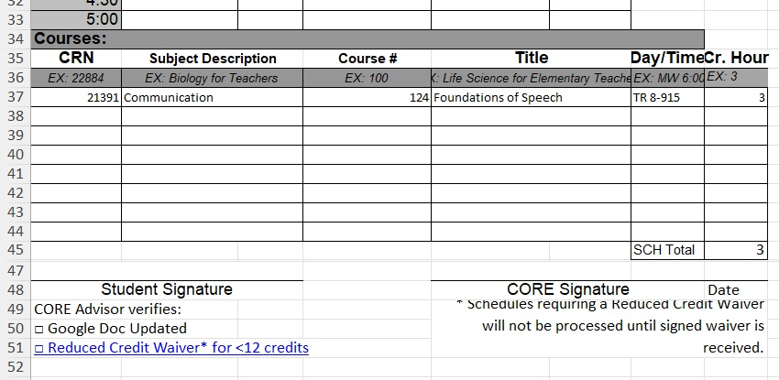

- You are almost done. You need to request enough credits to be considered a full time student. Students are considered full time if they are taking 12 or more credits. Sometimes, it is better if you take between 9 and 11 credits. If this is your situation, you will need to get a reduced credit waiver form signed.

- Once you have your schedule request completed, sign it and send/share/give it to your CORE who will check to make sure your request is meeting your requirements and that there are ECA spots available.

- If you do not know the name of a specific class
- you can search for classes by categories. For example, once you are in the Browse Classes screen, you can click in the subject area and it will generate a list of course categories.
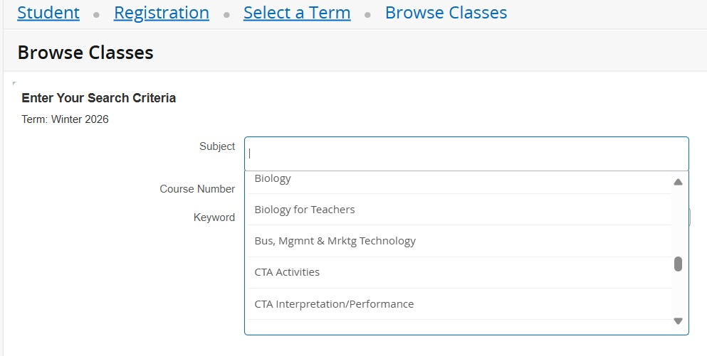
If you are interested in seeing what classes are offered for a subject (like biology), you can click on the subject name and it will list all of the classes offered in that subject.

- You can also use the advanced search to list all classes with a specific attribute
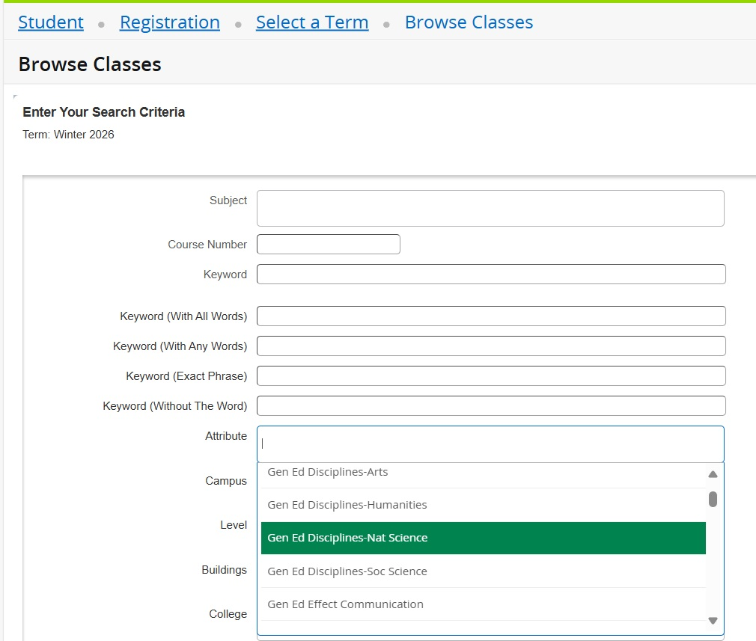
For example, if you are trying to find Humanities Gen Ed classes, you can click on the attribute and it will show all classes available with that attribute.

One last thing….
- This is more for students who are farther into the program and taking classes that require pre-requisites or co-requisites.
- Pre-requisite = class that you must pass before you can take this class
- Co-requisite = class you must take at same time (this is usually the case with science classes where you have to take both the lecture and lab portions simultaneously
- To determine whether or not a class you are interested in has pre-requisites or co-requisites, do the following:

- Look up the class following the previous instructions to get to the CRN. For example, let’s say you wanted to take Chem 123. You get to the list of choices:
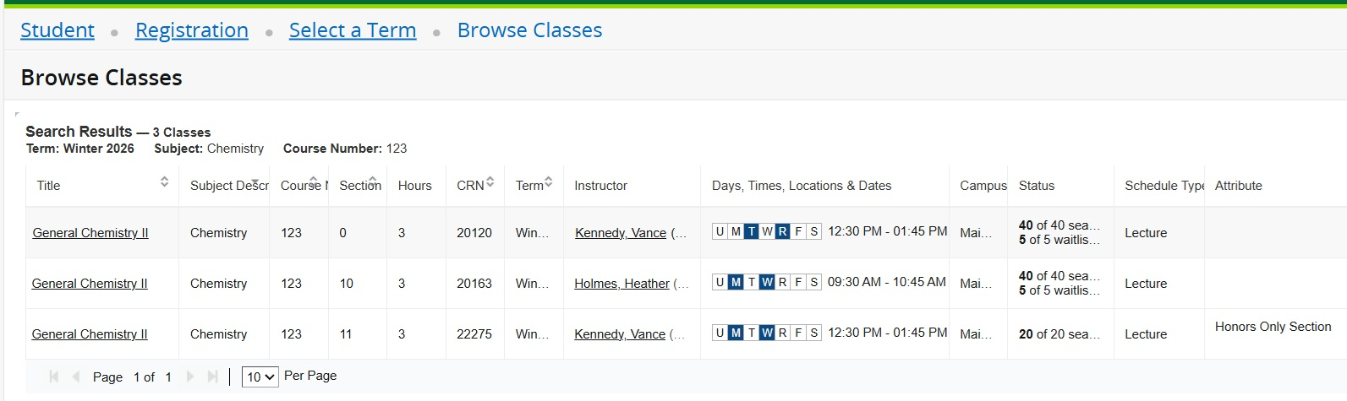
- You are interested in the MW 9:30-10:45 section. Now to check for pre-reqs and co-reqs. Click on the Title of the class (General Chemistry II). The next screen you get to looks like this:
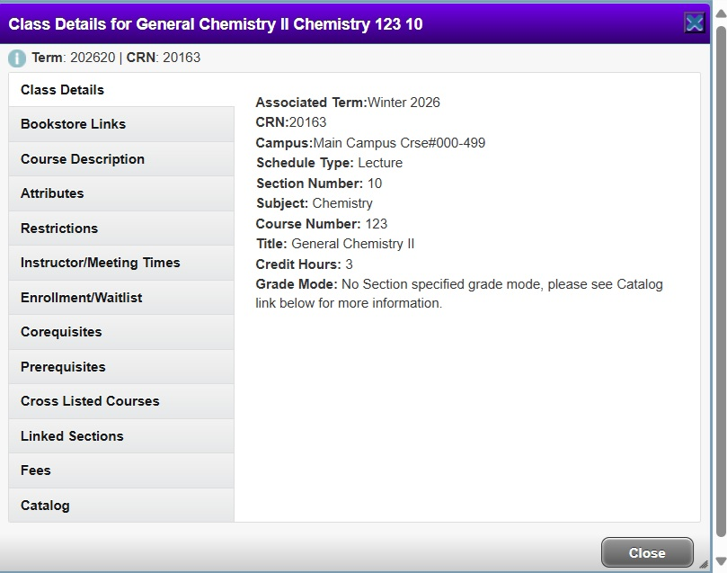
- Click on the Corequisites button to find out what class you have to take at the same time. For example:
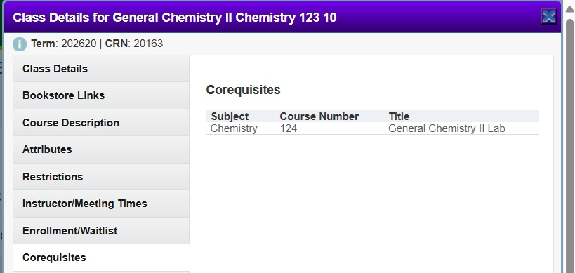

This tells you that you must take Chem 124 at the same time (co-requisite).
- Click on the Prerequisites button to find out what you need to have completed before taking this course. For example: 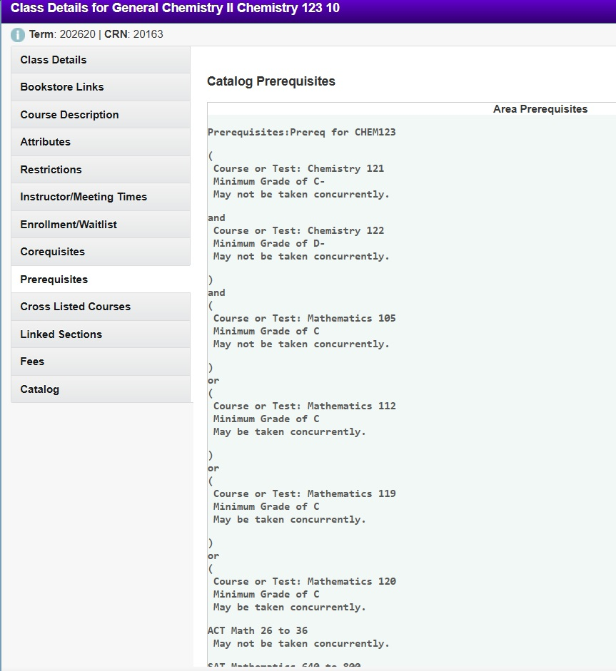
This means that you must have already completed Chem 121 and 122 and Math 105 or a higher level math before you will be allowed to register for this class.
Most classes will not have this long of a list of pre-req and co-req classes but you should be able to check whether or not you meet the requirements for the class you are interested in.

